Worth Steel & Machinery, Inc.
4001 W. 123rd Street Alsip, Illinois 60803
(708)388-6300 Fax(708)388-6467
www.worthsteel.com

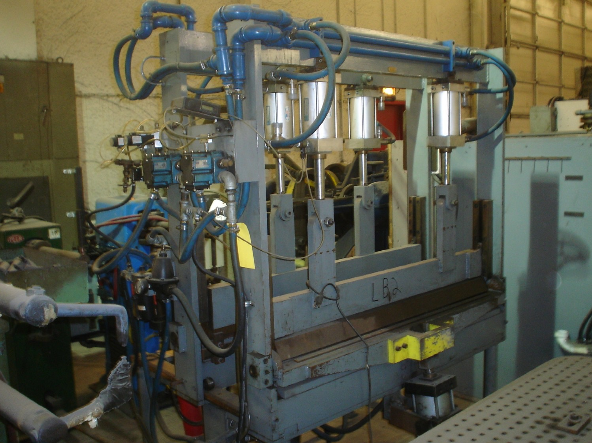
We are pleased to quote the following:

One Used Custom Basket Press

Operation Pneumatic
Width 72” between heads
Dimensions: 30” W x 52” L x 72” H
(machine)
Approx. Weight 850 lbs.
Condition Good
Stock Number 555

F.O.B. our warehouse, Alsip, IL available with a 30 day return privilege Price $ 4,500.00

Suppliers of Steel Wire and Fabricating Machinery

