Worth Steel & Machinery, Inc.
4001 West 123rd Street Alsip, IL 60803
(708)388-6300 Fax (708)388-6467
www.worthsteel.com

We are pleased to quote the following:

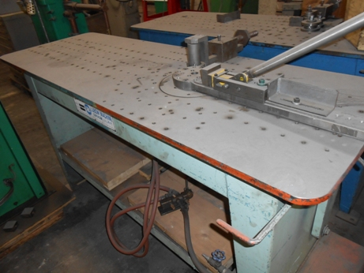

One Used Lubow Rotary Bender

Model ML10 2ST

Serial 050576
Disc 10”
Operation Pneumatic
Dimensions:
(machine) 24” wide x 72” long x 48” high
Tooling 1 set
Approx. Weight 1000 lbs.
Condition Good
Stock Number 689

F.O.B. our warehouse, Alsip, IL available with a 30 day return privilege Price $ 2,500.00

