Worth Steel & Machinery, Inc.
4001 West 123rd Street Alsip, IL 60803
(708)388-6300 Fax (708)388-6467
www.worthsteel.com

We are pleased to quote the following:
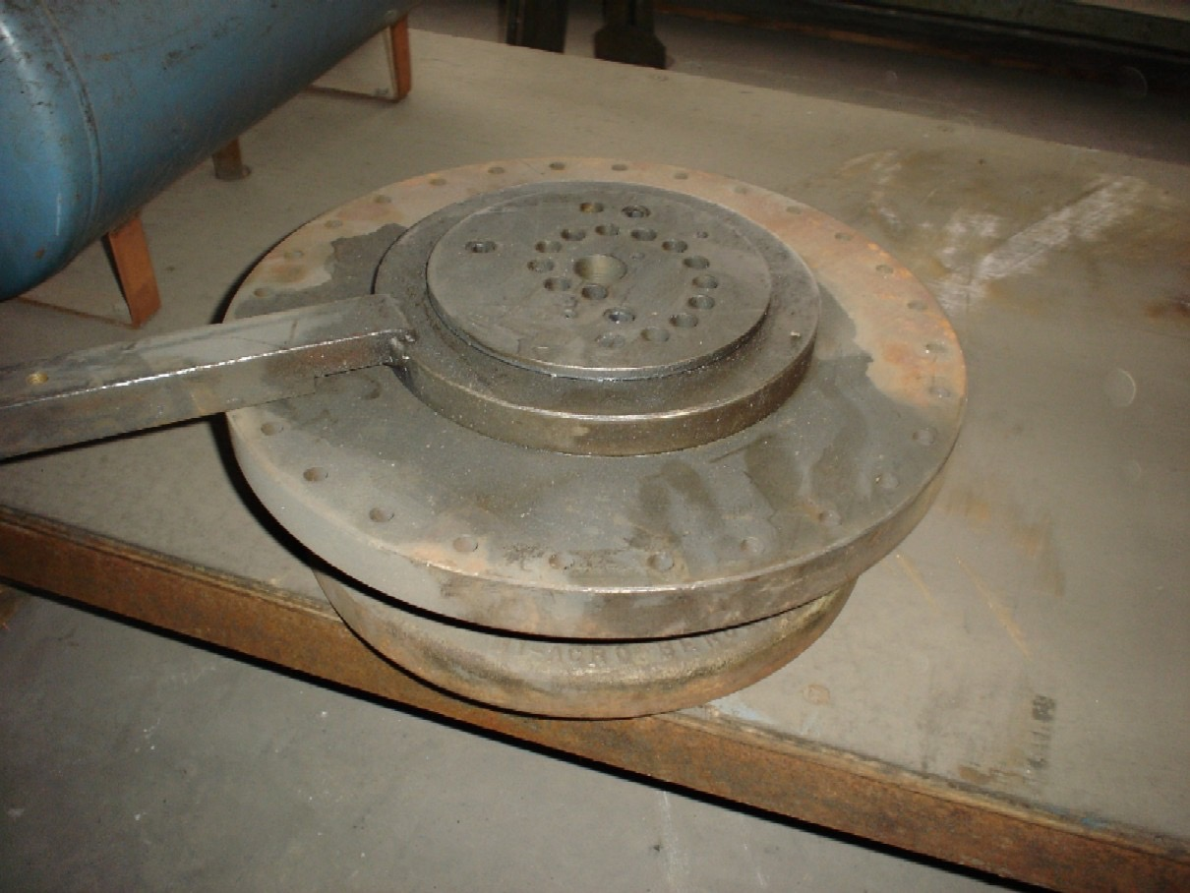

One Used Diacro Style Hand Bender

Model 2
Serial N/A
Dimensions:
(machine) 14” wide x 43” long x 12” high
Tooling none
Approx. Weight 100 lbs.
Condition Good
Stock Number 472

F.O.B. our warehouse, Alsip, IL available with a 30 day return privilege Price $ 550.00

