Worth Steel & Machinery, Inc.
4001 West 123rd Street Alsip, IL 60803
(708)388-6300 Fax (708)388-6467
www.worthsteel.com

We are pleased to quote the following:
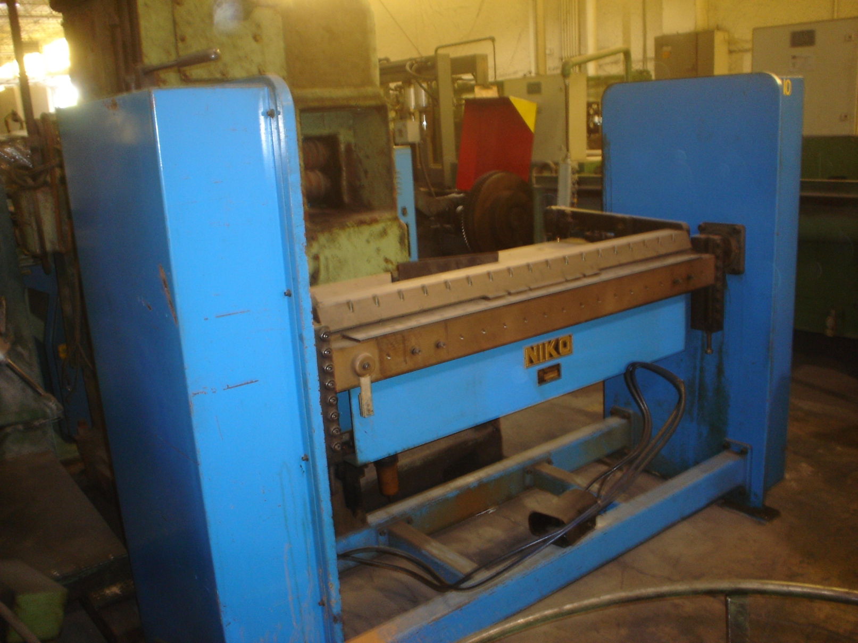

One Used Niko Folding Brake

Model 800

Serial 0995-0800
Capacity 72” max part
Operation Air
Dimensions:
(machine) 36” wide x 78” long x 60” high
Tooling 1 set included
Approx. Weight 1250 lbs.
Condition Good
Stock Number 662

F.O.B. our warehouse, Alsip, IL available with a 30 day return privilege Price $ 8,000.00

