Worth Steel & Machinery, Inc.
4001 West 123rd Street Alsip, IL 60803
(708)388-6300 Fax (708)388-6467
www.worthsteel.com

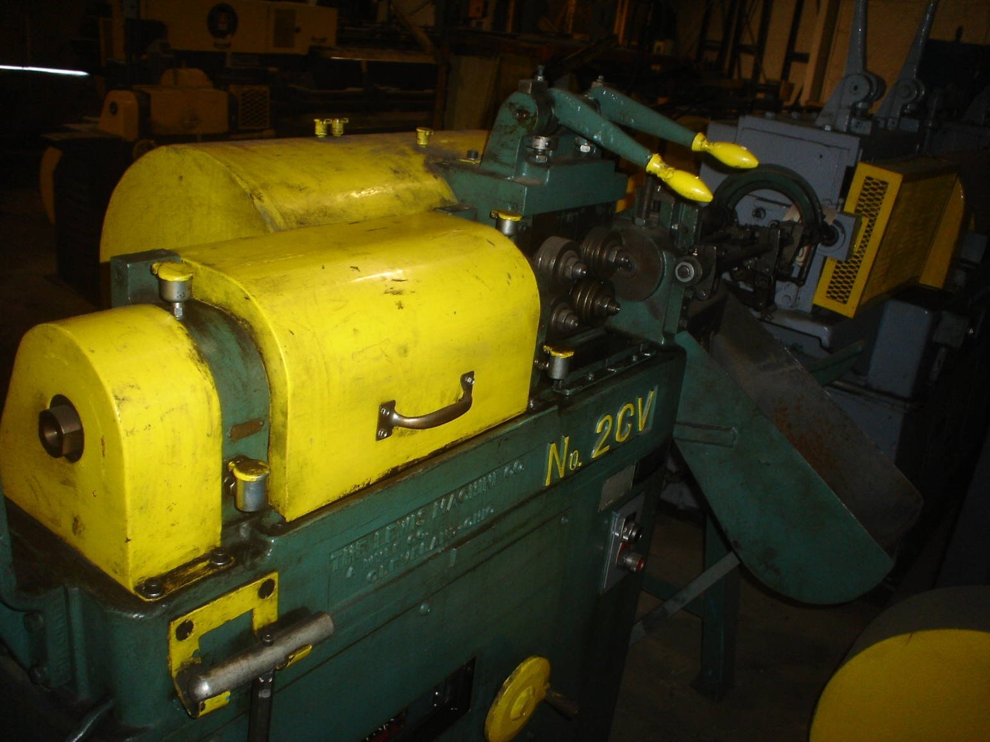
We are pleased to quote the following:

One Used Lewis Straighten and Cut Machine

Model 2CV

Serial 495
Capacity .062 - .312
Bed 18”
H.P. 10
Year 1971
Feed Rolls 2 after the arbor
Dimensions:
(machine) 36” wide x 60” long x 48” high
Tooling 1 set included
Approx. Weight 1800 lbs.
Condition Good
Stock Number 635

F.O.B. our warehouse, Alsip, IL available with a 30 day return privilege Price $ 12,000.00

