Worth Steel & Machinery, Inc.
4001 West 123rd Street Alsip, IL 60803
(708)388-6300 Fax (708)388-6467
www.worthsteel.com

We are pleased to quote the following:

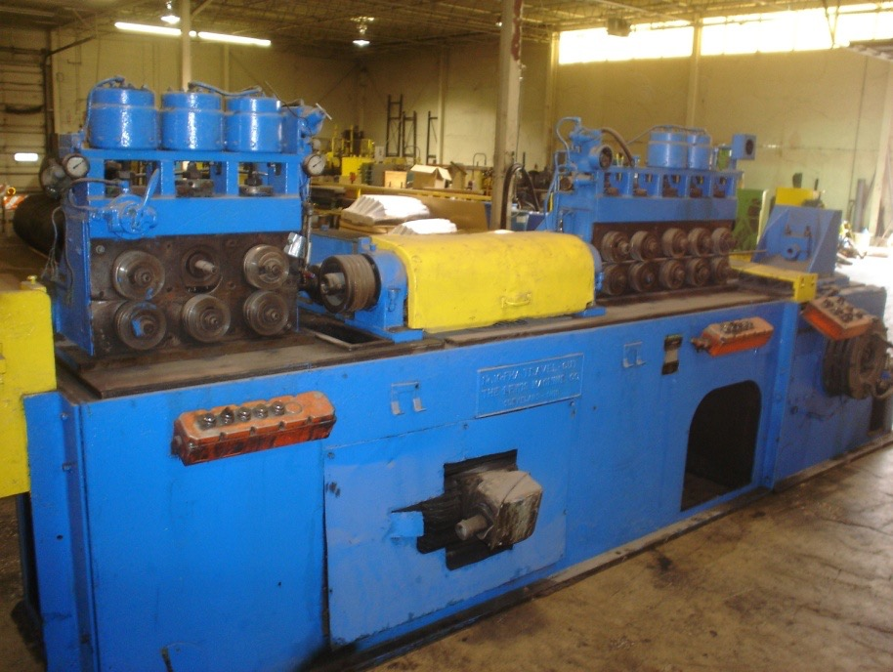

One Used Lewis Straighten and Cut Machine

Model 10 FHA Serial 103
Capacity .250 - .625
Bed 240”
H.P. 60
Year 1967
Speed 115 – 350 FPM
Feed Rolls 3 sets before and 5 sets after the arbor
Dimensions:
(machine) 58” wide x 380” long x 64” high
Tooling 1 set included
Approx. Weight 20000 lbs.
Condition Good
Stock Number 603

F.O.B. our warehouse, Alsip, IL available with a 30 day return privilege Price $ 89,000.00

