Worth Steel & Machinery, Inc.
4001 West 123rd Street Alsip, IL 60803
(708)388-6300 Fax (708)388-6467
www.worthsteel.com

We are pleased to quote the following:

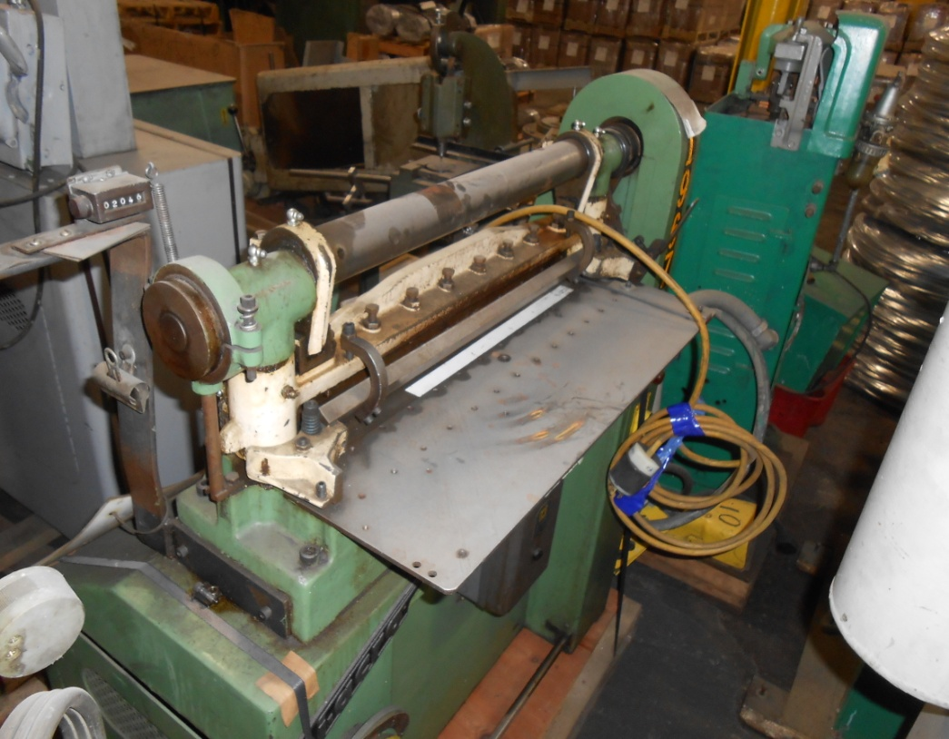

One Used Diacro Power Notcher

Model 1P

Serial AA - 1208
Capacity 16 gage sheet
Back gage 12”
Dimensions:
(machine) 24” wide x 24” long x 48” high
Approx. Weight 335 lbs.
Condition Good
Stock Number 725

Price F.O.B. our warehouse, Alsip, IL available with a 30 day return privilege $ 2,500.00

