Worth Steel & Machinery, Inc.
4001 West 123rd Street Alsip, IL 60803
(708)388-6300 Fax (708)388-6467
www.worthsteel.com

We are pleased to quote the following:

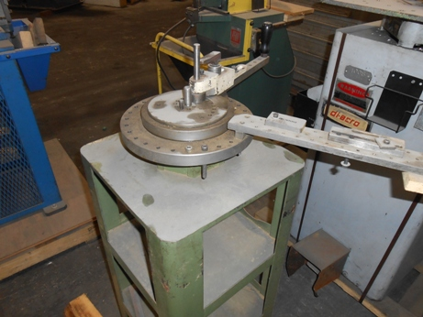

One Used Diacro Hand Bender with Stand

Model 1A

Serial 2734
Capacity .312 dia. Wire
.250 square
1/2” (16 gage) tubing
Radius 6” max
Center Pin 1”
Dimensions:
(machine) 12” wide x 12” long x 48” high stand included
Tooling 1 set included
Approx. Weight 70 lbs.
Condition Good
Stock Number 692

F.O.B. our warehouse, Alsip, IL available with a 30 day return privilege Price $ 750.00

