Worth Steel & Machinery, Inc.
4001 West 123rd Street Alsip, IL 60803
(708)388-6300 Fax (708)388-6467
www.worthsteel.com

We are pleased to quote the following:

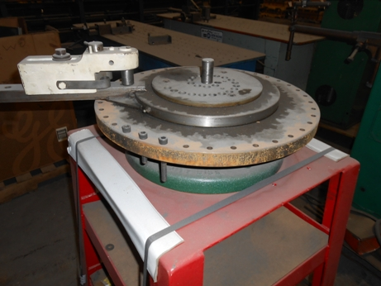

One Used Diacro Hand Bender with Stand

Model 3

Serial N/A
Capacity .625 dia. Wire
.500 square
1” (16 gage) tubing
Radius 12” max
Center Pin 1”
Dimensions:
(machine) 16” wide x 16” long x 48” high stand included
Tooling 1 set included
Approx. Weight 220 lbs.
Condition Good
Stock Number 695

F.O.B. our warehouse, Alsip, IL available with a 30 day return privilege Price $ 1,250.00

