Worth Steel & Machinery, Inc.
4001 West 123rd Street Alsip, IL 60803
(708)388-6300 Fax (708)388-6467
www.worthsteel.com

We are pleased to quote the following:

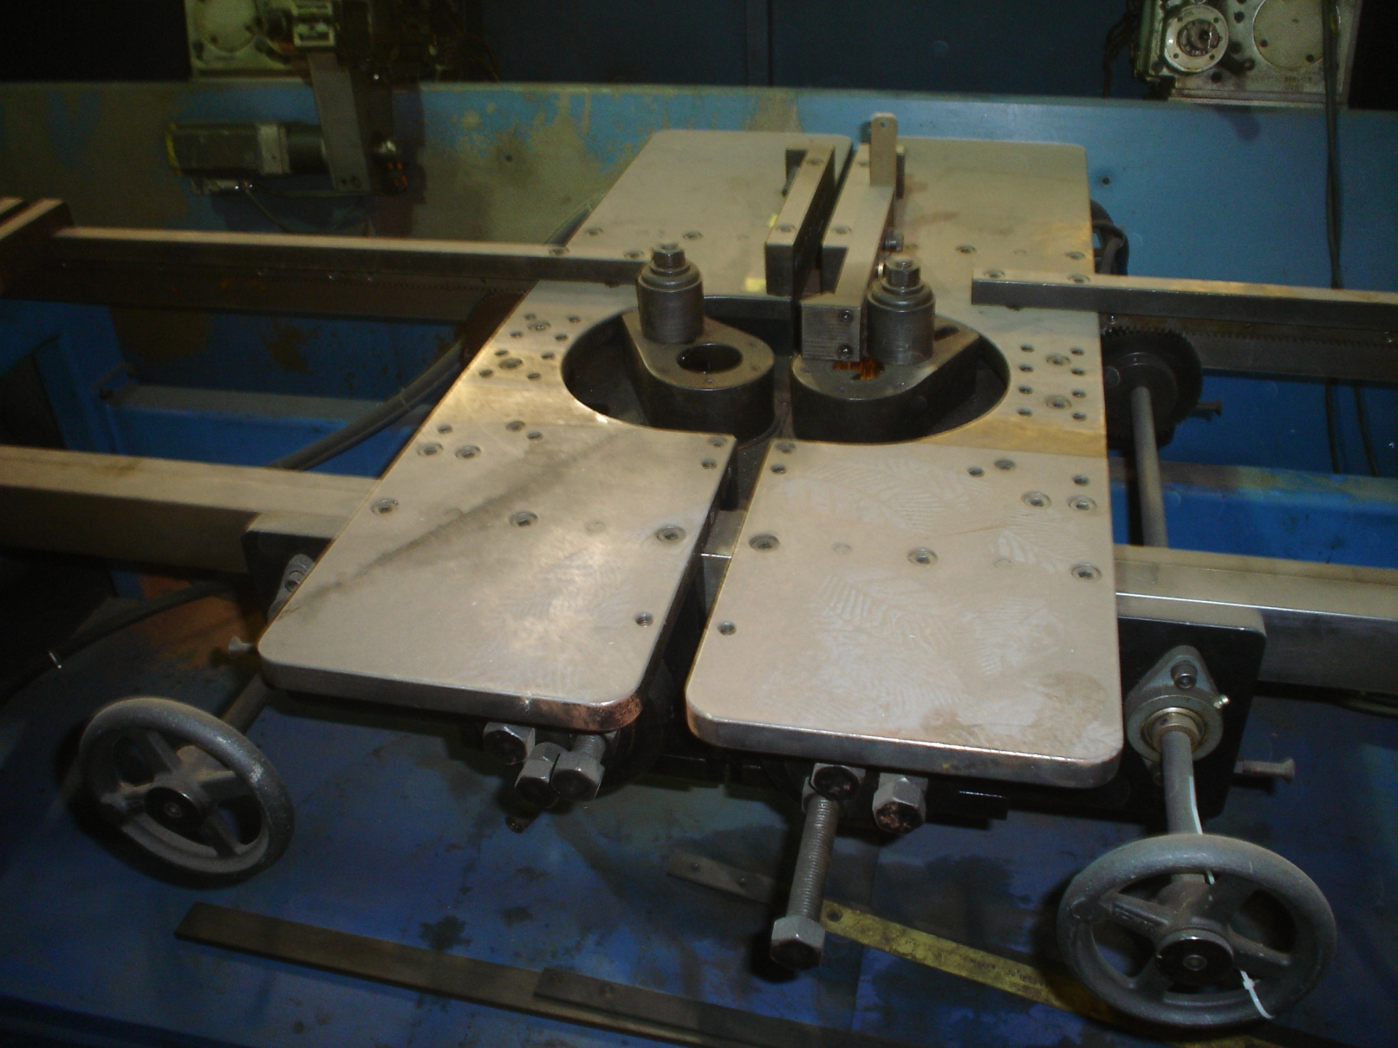

One Used Niko 2-Headed Bender

Model 969

Serial 1197-0969
Capacity 96” between heads, min. 6” between heads
Max. Diameter .500
Operation Air
Dimensions:

(machine) 36” wide x 100” long x 48” high
Tooling 1 set included
Approx. Weight 1500 lbs.
Condition Good
Stock Number 620

F.O.B. our warehouse, Alsip, IL available with a 30 day return privilege Price $ 7,500.00

