Worth Steel & Machinery, Inc.
4001 West 123rd Street Alsip, IL 60803
(708)388-6300 Fax (708)388-6467
www.worthsteel.com

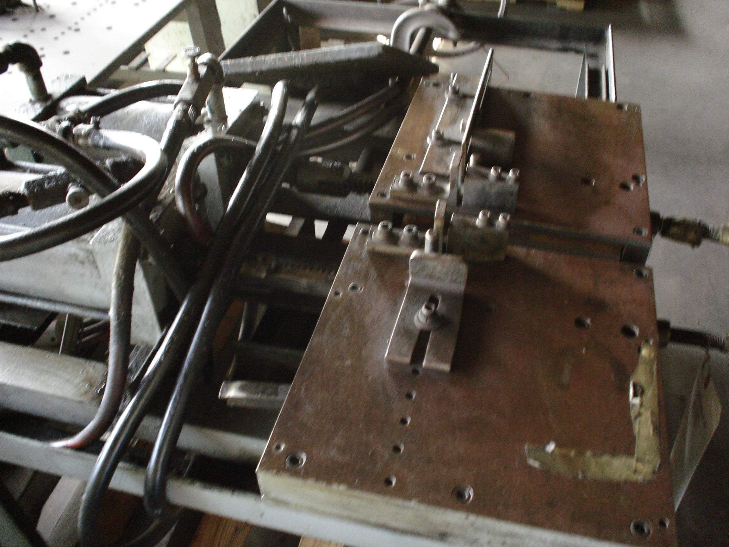
We are pleased to quote the following:

One Used Custom 2-Headed Air Bender

Model Custom

Serial N/A
Disc 3”
Max angle 90 degree
Dimensions:
(machine) 60” wide x 42” long x 48” high
Tooling none
Approx. Weight 1400 lbs.
Condition Good
Stock Number 408

F.O.B. our warehouse, Alsip, IL available with a 30 day return privilege Price $ 6,000.00

