Worth Steel & Machinery, Inc.
4001 West 123rd Street Alsip, IL 60803
(708)388-6300 Fax (708)388-6467
www.worthsteel.com

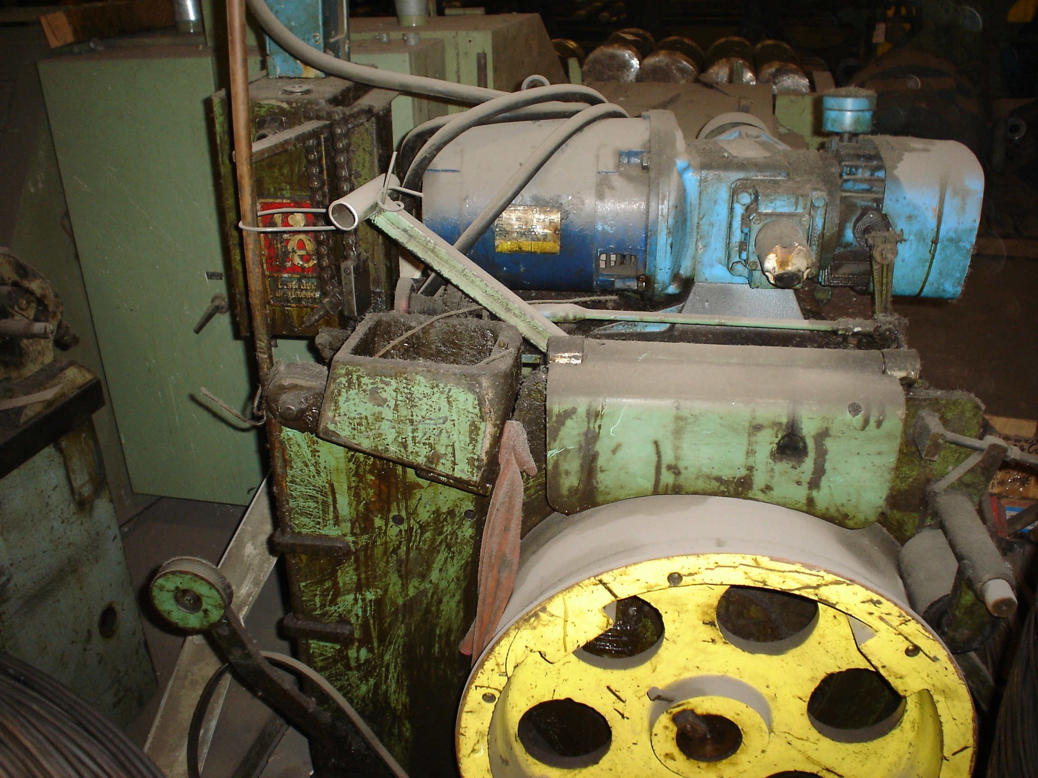
We are pleased to quote the following:

One Used Fastener Engineer In-Line Drawer

Model DH-230-210-24

Serial 17701164
Capacity .375 wire max
Speed 3 – 44 F.P.M.
H.P. 7 ½
Block 24”
Dimensions:
(machine) 60” wide x 72” long x 72” high
Approx. Weight 3500 lbs.
Condition Good
Stock Number 426

F.O.B. our warehouse, Alsip, IL available with a 30 day return privilege Price $ 5,000.00

